E-Commerce Sales Analytics Dashboard for Data-Driven Business Decision Making

Milan Jain
CSE
KL University
Hyderabad, India
2420030789@klh.edu.in
Nikhil Reddy
CSE
KL University
Hyderabad, India
2420030768@klh.edu.in
Varun Singh
CSE
KL University
Hyderabad, India
2420030039@klh.edu.in

Abstract—The rapid growth of online retail has produced large volumes of transactional data that offer little value to decision makers unless they are analyzed. This paper presents the design and implementation of an E-commerce Sales Analytics Dashboard that converts raw order, customer, product, and payment records into interactive visual insights. The workflow covers data collection, cleaning, feature engineering, exploratory analysis, and dashboard development using data science techniques. Key performance indicators such as total revenue, number of orders, average order value, growth rate, and repeat purchase rate are computed and presented alongside sales trends, product and category performance, regional distribution, and customer segments derived from recency, frequency, and monetary value analysis. Interactive filters allow users to explore the data by time period, product category, and region without technical expertise. The dashboard supports faster, evidence-based decisions in inventory planning, marketing, and customer retention, and illustrates how a well-structured analytics dashboard can turn complex sales data into clear, actionable information for online retailers.
Keywords—E-commerce, sales analytics, dashboard, data visualization, business intelligence, customer segmentation, data science

Introduction
Electronic commerce has changed the way products are bought and sold, and online retailers now record every order, payment, and delivery event. This continuous stream of transactional data is a valuable asset, yet its volume and variety make manual inspection through spreadsheets slow and error-prone. Business intelligence and analytics have therefore become central to competitive online retail, allowing organizations to move from intuition-based to evidence-based decisions [1], [2].
A dashboard is a visual display that consolidates the most important information on a single screen so that it can be monitored at a glance [3]. For sales teams, a dashboard allows managers to track revenue, identify best-selling products, understand customer behavior, and detect declining trends early without writing queries or code. In practice, however, sales reports are often static, delayed, and difficult to interpret, particularly for small and medium-sized sellers.
This project addresses that gap by developing an E-commerce Sales Analytics Dashboard using data science techniques. The main objectives are: (1) to clean and prepare raw e-commerce transaction data for analysis; (2) to compute meaningful key performance indicators (KPIs) that describe sales performance; (3) to analyze sales trends, product performance, regional patterns, and customer behavior; and (4) to present the results in an interactive dashboard that supports business decisions.
The remainder of this paper is organized as follows. Section II reviews related work, Section III describes the methodology, Section IV discusses the results, and Section V concludes the paper with directions for future work.

Related Work
Business intelligence and analytics has evolved from database-centric reporting toward web-based and big data analytics [1]. Chaudhuri et al. describe the core technology of business intelligence, which includes data integration, data warehousing, and reporting and visualization tools that deliver information to decision makers [4].
Dashboard design has been studied from the perspective of visual communication. Few emphasizes that effective dashboards present only the most important information, use appropriate chart types, and avoid clutter so that users can understand a situation quickly [3]. These principles guide the layout of the dashboard proposed in this work.
In customer analytics, recency, frequency, and monetary value (RFM) analysis is a widely used technique for describing customer behavior from transaction histories. It summarizes when a customer last purchased, how often the customer purchases, and how much the customer spends [5].
Exploratory data analysis, introduced by Tukey, emphasizes examining data through summary statistics and graphics before any formal modeling [6]. Modern data science tools such as the pandas library for data manipulation [7] make these steps efficient and reproducible. Building on these foundations, this work integrates data preparation, KPI computation, customer segmentation, and interactive visualization into a single dashboard tailored to e-commerce sales.

Methodology
The proposed system follows the data science life cycle, from data collection to dashboard delivery, as shown in Fig. 1.
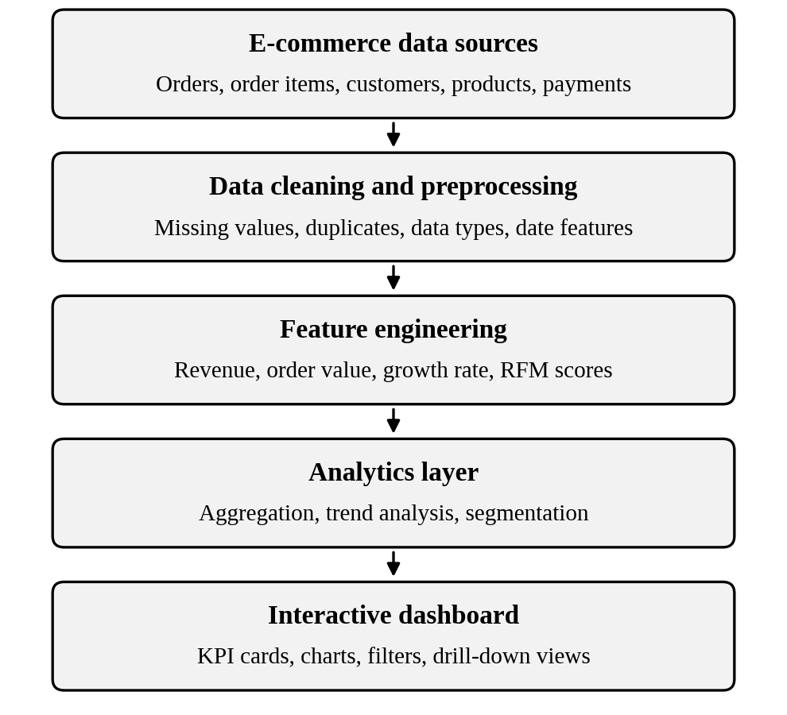
- Overall workflow of the E-commerce Sales Analytics Dashboard.

Data Collection and Description
The dashboard is built on transactional e-commerce data consisting of order records, order items, customer details, product information, and payment records. Each order is associated with a purchase timestamp, a customer identifier, one or more products with their categories and prices, a payment value, and a delivery location. These related tables are joined using order, customer, and product identifiers to create a single analysis-ready dataset.

Data Preprocessing
Raw data was cleaned before analysis to ensure the reliability of the results. The following steps were performed in Python using the pandas library [7]:
- Duplicate records were identified and removed.
- Missing values were imputed or removed depending on the importance of the field.
- Date fields were converted to a standard date-time format, and day, month, quarter, and year were extracted.
- Numeric fields such as price and payment value were converted to the correct data types.
- Cancelled and invalid orders were excluded from revenue calculations.

Key Performance Indicators
KPIs summarize business performance in a small number of measurable values. Table I lists the indicators used in the dashboard. Let R denote the total revenue and N the number of distinct orders in a selected period. The average order value (AOV) is given by
AOV = R / N (1)
Let R_{t} be the revenue in month t. The month-over-month growth rate G_{t}, expressed as a percentage, is
G_{t} = (R_{t} − R_{t−1}) / R_{t−1} × 100 (2)
The repeat purchase rate (RPR) is the share of customers who placed more than one order. With C_{rep} repeat customers out of C_{tot} customers in total,
RPR = (C_{rep} / C_{tot}) × 100 (3)
- Key Performance Indicators Used in the Dashboard
KPI | Description
Total revenue | Sum of the sales value of all valid orders in the selected period
Number of orders | Count of distinct valid orders
Average order value | Revenue divided by the number of orders, as in (1)
Revenue growth | Month-over-month change in revenue, as in (2)
Repeat purchase rate | Percentage of customers with more than one order, as in (3)
Top products | Products ranked by revenue and units sold
Category share | Contribution of each product category to total revenue

Exploratory Analysis and Customer Segmentation
Exploratory data analysis was carried out to understand sales patterns before the dashboard was built [6]. Revenue and order counts were aggregated by day, month, and year to reveal trends and seasonality, and by product category and region to compare performance. Customer behavior was analyzed using RFM analysis [5]. For each customer, recency is the number of days since the last purchase, frequency is the number of orders, and monetary value is the total amount spent. Each measure is converted into quantile-based scores, and the combined scores are used to group customers into segments such as champions, loyal customers, at-risk customers, and lost customers.

Dashboard Design and Implementation
The dashboard is organized into five pages, summarized in Table II. Following the principle of showing the most important information first and keeping each view uncluttered [3], the overview page presents headline KPIs at the top, and the remaining pages provide detailed analysis. A global filter panel lets users select the date range, product category, and region, and all charts update accordingly. Each chart carries a clear title and labeled axes, with units shown in parentheses.
- Dashboard Modules and Visualizations
Module | Visualization | Purpose
Overview | KPI cards | Show headline performance at a glance
Sales trends | Line chart | Track revenue and orders over time
Products | Bar chart | Rank products and categories
Regions | Geographic chart | Compare sales across locations
Customers | Segment chart | Show RFM segment sizes and value

Results and Discussion
This section describes the analytical views provided by the dashboard and the insights that they make available to decision makers.

Sales Performance Overview
The overview page presents total revenue, number of orders, average order value, and growth rate as KPI cards at the top of the screen, giving managers an immediate summary of business health. Time-series line charts show how revenue and order volume change by day, month, and year. These views make seasonal peaks, promotional spikes, and periods of decline easy to identify, which supports timely planning of campaigns and stock levels.

Product and Category Analysis
Bar charts rank products and categories by revenue and units sold. This allows managers to distinguish high-revenue categories from low-performing ones and to see how strongly total revenue depends on a small number of products. Such information supports decisions on inventory allocation, pricing, and promotion of underperforming items.

Regional and Customer Analysis
The regional view compares sales across locations, helping to identify high-demand markets and areas with growth potential. The customer view displays the RFM segments and the repeat purchase rate. By separating high-value loyal customers from at-risk and lapsed customers, a business can design targeted retention offers instead of uniform discounts.

Discussion
Compared with static spreadsheet reports, an interactive dashboard is expected to reduce the time needed to answer common business questions, since users can filter and drill down without writing queries. The main advantages of the proposed approach are as follows:
- Centralized view: all KPIs and analyses are available in one place.
- Interactivity: filters let users explore the data by period, category, and region.
- Actionable insights: trend and segmentation views link directly to marketing, inventory, and retention decisions.
- Reproducibility: the preprocessing and analysis pipeline can be re-run when new data becomes available.
The limitations of the current work are the use of historical data only, the absence of predictive modeling, and the dependence of the results on the quality of the underlying records.

Conclusion and Future Work
This paper presented an E-commerce Sales Analytics Dashboard that transforms raw transactional data into interactive insights through data cleaning, KPI computation, exploratory analysis, RFM segmentation, and visual design. The dashboard gives business users a clear and consolidated view of sales performance, product demand, regional patterns, and customer behavior, and thereby supports evidence-based decisions.
Future work includes adding sales forecasting with time-series models, product recommendation based on purchase history, near real-time data feeds, and customer churn prediction. Incorporating external factors such as promotions and holidays could further improve the accuracy and usefulness of the insights.

Acknowledgment
The authors thank the course faculty for their guidance and support during this project.

References
- H. Chen, R. H. L. Chiang, and V. C. Storey, “Business intelligence and analytics: From big data to big impact,” MIS Quarterly, vol. 36, no. 4, pp. 1165–1188, Dec. 2012.
- F. Provost and T. Fawcett, Data Science for Business. Sebastopol, CA: O’Reilly Media, 2013.
- S. Few, Information Dashboard Design: The Effective Visual Communication of Data. Sebastopol, CA: O’Reilly Media, 2006.
- S. Chaudhuri, U. Dayal, and V. Narasayya, “An overview of business intelligence technology,” Commun. ACM, vol. 54, no. 8, pp. 88–98, Aug. 2011.
- P. S. Fader, B. G. S. Hardie, and K. L. Lee, “RFM and CLV: Using iso-value curves for customer base analysis,” J. Marketing Res., vol. 42, no. 4, pp. 415–430, Nov. 2005.
- J. W. Tukey, Exploratory Data Analysis. Reading, MA: Addison-Wesley, 1977.
- W. McKinney, “Data structures for statistical computing in Python,” in Proc. 9th Python in Science Conf. (SciPy), 2010, pp. 56–61.

